12.10.2017

BLOG POST Evidence-based policies, Giovanna di Marzo

This morning, Giovanna Di Marzo Serugendo (professor at the University of Geneva and the head of the Institute of Services Science.Director, Inst. Services Science & CUI, UNIGE) gave us a course on “evidence-based policy making”, which refers, according to the UN definition, to “*a policy process that helps planners make better-informed decisions by putting the best available evidence at the centre of the policy process*”.

Through this particular approach it is possible to identify a concrete problem, help for choosing a suitable policy, foresee a policy’s success, monitor its implementation, and finally evaluate the impact of a policy, to be then communicated to the public.

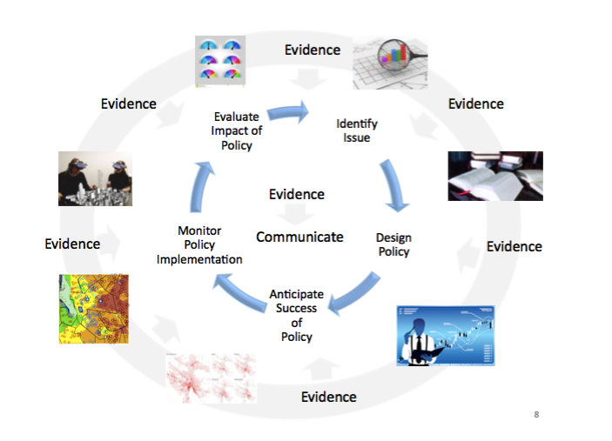

As we can see, evidences are at the core and at each step for every efficient policy-making process. They can be based on research, case studies, expert advice, data, etc. and can be used to collect data, visualize the information in order to have an insight of the current situation, and highlight the eventual need for a new policy implementation or a change. Furthermore, evidences can be used  to do simulations and projections to predict the future.

This kind of policy offers many different ways of application: as shown by the professor, the City of Geneva in partnership with a local phone company, was able to map and visualize the digital traces created by the population’s mobile phones. This useful data can be used for urban planning strategies, or setting restaurants, parking places, based on these streams of connected people in our hyper-connected world.

**

Voici le projet: <https://villevivante.ch/#background>

Another very intuitive and effective example for using data, is what Tesco (a retailer chain based mainly in the UK) does with the data they collect from their customers Clubcard. Having access to their customers’ addresses (information they get when customers sign up for this service), they are able to know best where to locate their next branch, and where it suits the best the needs of the customers.

As a follow-up, we had a chance to have a go in this policy making process

by taking inspiration from professor Di Marzo Serugendo’s examples: especially, two ideas were particularly pertinent.

The first consisted in increasing educated youth employment: the intuition is that areas around certain universities which have specific expertise, will be full of graduate students experts in those particular fields, and living in the region. Therefore, this would be the best zones for companies to set up their lab according to their needs.

Another interesting idea was aimed at improving the education system, and for countries to learn the best practices and systems based on data collected by the

OECD’s Pisa 2015 survey. What we found is that students score differently according to their ethnicity: this finding prompt to the idea to look at how the educative system of each country can be improved by learning best practices among each other.

We have been surprised in realizing how were visualizations helpful to understand a problem and how they were easy to interpret instead of data-base for instance. but at the same time, we realise that there are all sorts of risk regarding privacy that comes with this kind of policy making. As pointed out by the professor as well, along with these innovative ways of making policies, there’s also need to simultaneously provide data protection and privacy.

Written by Tina Laa and Amaëlle Grosjean